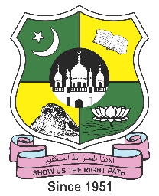
JAMAL MOHAMED COLLEGE (AUTONOMOUS)
Accredited (3rd cycle) with ‘A’ Grade by NAAC
(Affiliated to Bharathidasan University)
TIRUCHIRAPPALLI – 620 020
PG & RESEARCH DEPARTMENT OF COMMERCE (SF-WOMEN)
Report on Teachers Day Celebration 2022-23
Event 1 : Exhibition on Contribution of Teachers to Education.
Date & Time : 09th September,2022, Friday at 3.00 pm – 5.30 pm
Venue : Room No. LH – 254
Event 2 : Essay Writing Competition.
Event 3 : Oratorical Contest.

Topic : “TEACHERS BUILD FUTURE” &
“WHY I LOVE MY TEACHER?”

Date&Time : 09th September,2022 ,Friday at 3:30 pm – 5:00pm

Venue : Room No. LH – 191 & 192

With the blessings of Almighty God and the ever-encouraging support of our benevolent Management, the PG & Research Department of Commerce (SF- Women) have organized various competitions for the students in recognition of the valuable services rendered by the Teachers. The Teacher’s Day function started at 3.00 pm.

The function started with an Exhibition on the Contribution of Teachers for upliftment of the students community. The exhibition programme was inaugurated by HOD and staff members who graced the Teacher’s Day Programme with their august presence. Many students participated in Essay Writing competition and in Oratorical contest on the theme of “Teacher’s Day”. On that day members of student representative along with the Vice President took over the responsibility in organizing the functions effectively of teaching as a symbol of gratitude to the teachers.

In the end all the students thanked all the teachers for providing a great education.

Around 100 students attended the programme and got benefited out of it.

